Rain Bird IQ4 Communications Checklist

Rain Bird IQ - NCC 3G Cartridge

- Verify the status of the Cellular Data Plan for the IQ Cartridge
  - IQ3
    - Select Satellite through “Satellites” -> “Configure…”
    - Select “Edit Configuration and Stations…”
    - Verify the expiration of the cellular data plan from the information displayed in the “Type” section
    - If the Cellular Data Plan has expired, renew it through “Help” -> “Cellular Data Plan Renewal”
  - IQ4:
    - When logging into IQ4-Cloud, a banner will appear at the top of the webpage indicating the need to renew one or more cellular plans for the controllers listed in your system
- Check all connections (antenna, cable to front panel, IQNet cables)
- Check IQ communications (Sync, Reverse Sync, Log Retrieval)
- Verify the status of the IQ Cartridge
  - Check status of the IQ LED on the back of the cartridge: 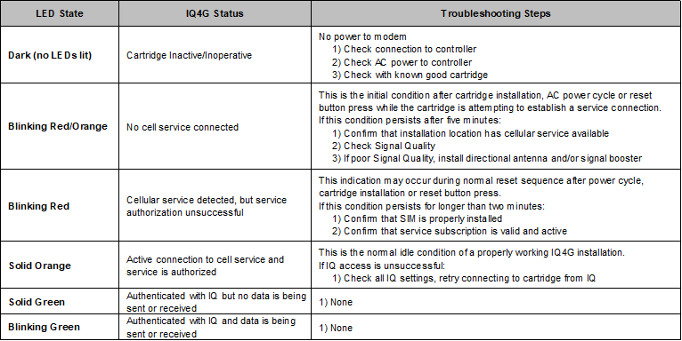
- ESP LXME/ESP LXD: Turn the dial to “IQ Settings”
- ESP LXIVM: Turn the dial to “Advanced Settings” -> “Configure Cartridge”
- Select “Status” using the arrow and Next button
- Verify the status of the IQ Cartridge
- IQ 3G Cartridge Communication Ports
  - The 3G cartridge has 3 communication ports:
    - IQ – Primary Cellular communication with IQ
    - Radio – Secondary radio communication with Client controllers
    - CM – Secondary Connection Module communication with Client controllers
- Verify the status of the IQ Port
  - Resetting – Cartridge is resetting itself prior to connection attempt
  - No Service – Cartridge has no connection to the local Cellular tower or the service.
  - If this condition persists after five minutes:
    - Confirm that installation location has cellular service available
    - Check Status/Signal Quality
    - If poor Signal Quality, install directional antenna and/or signal booster
  - Connecting – Cartridge is trying to establish a connection to the local Cellular tower and Internet service
  - Idle – Active connection to cellular tower & service is authorized; Waiting for a connection from IQ
  - Connected – IQ is connected to the cartridge
  - Connected/Active – IQ is connected and data is being transferred between IQ and the cartridge
- Verify the status of the IQ Cartridge Ports
  - Radio Port Status (Server configuration only):
    - Disabled – Configured as “Radio Not Installed”
    - No Service – Cartridge is not connected to a powered radio
    - Connected – Cartridge is connected to the radio and it is trying to communicate with Client controller(s)
    - Connected/Active – Data is being transferred between Server and Client controller(s)
  - CM Communication Module Port Status (Server configuration only):
    - Disabled – Configured as “CM Module Not Installed”
    - Connected – Cartridge is connected to CM Module and it is trying to communicate with Client controller(s)
    - Connected/Active - Data is being transferred between Server and Client controller(s)
- Select “Signal using the button
- Signal Strength Indications:
  - 1 - 2 = POOR signal strength, consider signal booster or directional antenna
  - 4 - 7 = Good signal strength - good connection
  - 8 - 10 = Excellent signal strength - excellent connection
- If the signal strength is below 2
  - Use IQ4GEXTANT Cellular External Antenna if the controller is in a metal enclosure
  - Relocate antenna where cellular strength is above 2
  - Install Directional 3G Antenna listed below
  - Install Signal Booster listed below for 3G
- Additional Steps
  - Try a different known-to-be-active SIM card in the cartridge
  - Make sure the latest NCC firmware is installed in the cartridge
  - If the device has worked before, trace back to changes that may have caused the cartridge to stop working and note those

Rain Bird IQ - NCC 4G Cartridge

- Verify the status of the Cellular Data Plan for the IQ Cartridge
  - IQ3:
    - Select Satellite through “Satellites” -> “Configure…”
    - Select “Edit Configuration and Stations…”
    - Verify the expiration of the cellular data plan from the information displayed in the “Type” section
    - If the Cellular Data Plan has expired, renew it through “Help” -> “Cellular Data Plan Renewal”
  - IQ4:
    - When logging into IQ4-Cloud, a banner will appear at the top of the webpage indicating the need to renew one or more cellular plans for the controllers listed in your system
- Check all connections (antenna, cable to front panel, IQNet cables)
- Check IQ communications (Sync, Reverse Sync, Log Retrieval)
- Verify the status of the IQ Cartridge
  - Check status of the IQ LED on the back of the cartridge:
- ESP LXME/ESP LXD: Turn the dial to “IQ Settings”
- ESP LXIVM: Turn the dial to “Advanced Settings” -> “Configure Cartridge”
- Select “Status” using the arrow and Next button
- Verify the status of the IQ Cartridge
- IQ 4G Cartridge Communication Ports
  - The 4G cartridge has 3 communication ports:
    - IQ – Primary Cellular communication with IQ
    - Radio – Secondary radio communication with Client controllers
    - CM – Secondary Connection Module communication with Client controllers
- Verify the status of the IQ Port
  - Resetting – Cartridge is resetting itself prior to connection attempt
  - No Service – Cartridge has no connection to the local Cellular tower or the service.
  - If this condition persists after five minutes:
    - Confirm that installation location has cellular service available
    - Check Status/Signal Quality
    - If poor Signal Quality, install directional antenna and/or signal booster
  - Connecting – Cartridge is trying to establish a connection to the local Cellular tower and Internet service
  - Idle – Active connection to cellular tower & service is authorized; Waiting for a connection from IQ
  - Connected – IQ is connected to the cartridge
  - Connected/Active – IQ is connected and data is being transferred between IQ and the cartridge
- Verify the status of the IQ Cartridge Ports
  - Radio Port Status (Server configuration only):
    - Disabled – Configured as “Radio Not Installed”
    - No Service – Cartridge is not connected to a powered radio
    - Connected – Cartridge is connected to the radio and it is trying to communicate with Client controller(s)
    - Connected/Active – Data is being transferred between Server and Client controller(s)
  - CM Communication Module Port Status (Server configuration only):
    - Disabled – Configured as “CM Module Not Installed”
    - Connected – Cartridge is connected to CM Module and it is trying to communicate with Client controller(s)
    - Connected/Active - Data is being transferred between Server and Client controller(s)
- Select “Signal using the button
- Signal Quality is calculated from multiple parameters (RSSI and RSRP)
- Signal Quality will give a good indicator of IQ ability to communicate with a cellular cartridge
- Signal Quality Indications:
  - 1 = POOR signal quality, consider signal booster or directional antenna
  - 2 - 5 = Fair signal quality
  - 6 – 9 = Good signal quality - good connection
  - 10 = Excellent signal quality - excellent connection
- If the signal quality is below 2
  - Use IQ4GEXTANT Cellular External Antenna if the controller is in a metal enclosure
  - Relocate antenna where cellular quality is above 1
  - Install Directional 4G Antenna listed below
  - Install Signal Booster listed below for 4G
- Verify the Cellular Signal Quality
  - In the Signal Quality screen press “Detail” to get details on Signal Strength and Signal Quality
  - Detail:
    - RSSI - Received Signal Strength Indicator is a negative value, and the closer to 0, the stronger the signal
    - SINR - Signal to Interference plus Noise Ratio is the strength of the signal divided by the strength of any interference
    - RSRQ - Reference Signal Received Quality indicates the quality of the received reference signal
    - RSRP - Reference Signal Received Power is the power of the 4G Reference Signals spread over the full bandwidth
    - Tower: indicates the tower ID that the cartridge is connected to
  - RSSI for 4G/LTE is calculated from several other signal related measurements: RSSI = noise + serving cell power + interference power.
    - For example, a 4G LTE modem might report an RSSI of -68 dBm, but:
      - RSRP = -102 dBm
      - RSRQ = -16 dB
      - SINR = -1.8 dB
    - In this case, the signal quality is actually very poor. This could be due to the device being some distance away from the 4G transmitter or something is interfering with the signal, such as a building or other obstruction between the device and the tower.
- Additional Steps
  - Try a different known-to-be-active SIM card in the cartridge
  - Make sure the latest NCC firmware is installed in the cartridge
  - If the device has worked before, trace back to changes that may have caused the cartridge to stop working and note those
